What is SQL?
SQL or Structured Query Language is a programming* language. It was one of the first languages to utilize Codd's relational model, and although it does not follow his model completely it has become one of the most popular database language.
* It's technically not a programming language, it's actually a domain-specific language, which means its specialized for a specific function, in this case managing data in relational-databases.
You can use SQL to interact between most relational-database systems, and even though it's a standardized langue by both the ANSI [American National Standards Institute] and ISO [International Organization for Standardization], you'll typically have to modify and adjust code between database systems.
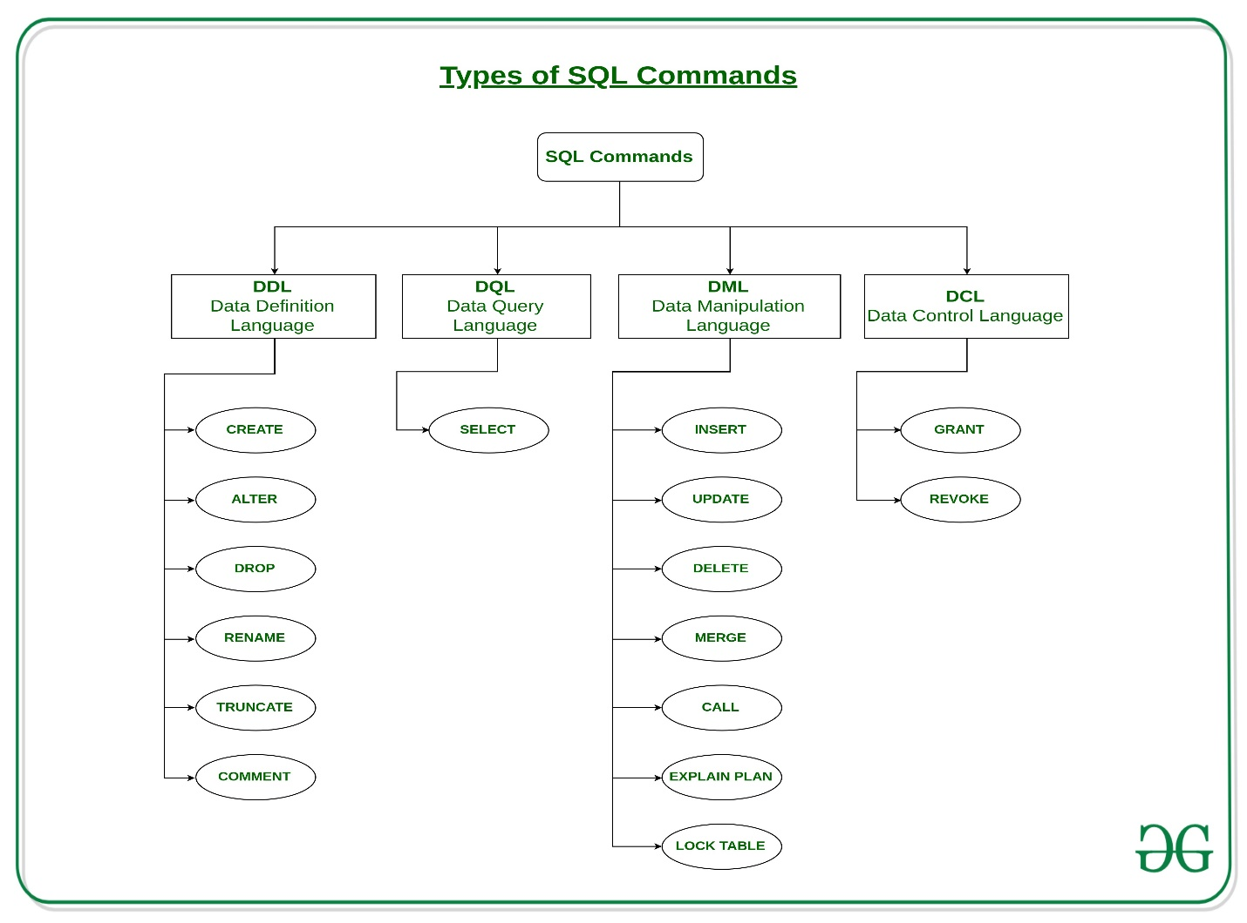

Running SQL Queries in Microsoft's SQL Management Studio
First you need to open a new Query window, you can do this by Selecting the New Query button:
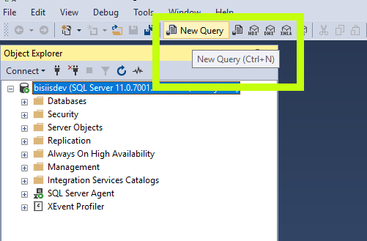
This will open a query window, this window is where you'll write and test your code, you can save this as ".sql" files for future execution.
Running and executing queries can be done of clicking pressing F5. You can execute sections of code by highlighting the code you wish to execute, and following the previous steps.

Lets try to run a query!
The first query we're going to run is a create table query, this will allow us to create a table to hold some data, the syntax for a create command is as follows:
CREATE TABLE table_name (
column1 datatype,
column2 datatype,
column3 datatype,
....
);
Using that syntax as an example, create the following table:
Student
ID | Int
FirstName | nvarchar(35)
LastName | nvarchar(40)
Address | nvarchar(255)

Dropping (Or deleting) Objects
The the usual keyword for removing an object from your database is DROP. Let's drop the table we just created:
DROP TABLE STUDENT;

Primary Keys
Primary keys' are important they server 2 main purposes. First they uniquely identify a record, second they are often use to create an index on a table, that allows the DBMS to more quickly search records.
Let's recreate our student table, but this time with a primary key:
CREATE TABLE Student(
ID int NOT NULL,
LastName nvarchar(35) NOT NULL,
FirstName nvarchar(40),
Address nvarchar(255),
PRIMARY KEY (ID)
);

Altering a Table
If you need to alter a table, for example you want to add a column, or remove a primary key you can use the ALTER command:
ALTER TABLE table_name
ADD column_name datatype;
Now alter the student table, so that you can add 2 columns for City - nvarchar(55) NOT NULL and Province char(2).

Foreign Keys
Using the ERD example we had discussed in the class on ERD's lets create some tables so that we can add relationships to them, make sure your database has the following tables:
This one should already exist.
Student
PK ID | Int - NOT NULL
FirstName | nvarchar(35)
LastName | nvarchar(40) - NOT NULL
Address | nvarchar(255)
City | nvarchar(55) - NOT NULL
Province | char(2)

Course
PK CourseCode | CHAR(7) - NOT NULL
Title | nvarchar(50)
Fee | money
Instructor | int - NOT NULL

Student_Course
PK StudentID | Int
PK CourseCode | Char(7)
Now that we have all the tables we need we can add in our foreign key, when adding a foreign key it's important it goes on the table with out the primary key being linked:
ALTER TABLE Student_Course
ADD CONSTRAINT FK_StudentID
FOREIGN KEY (StudentID) REFERENCES Student(ID);
So given this we can determine that the format for altering a table to add a FK is:
ALTER TABLE table_name
ADD CONSTRAINT constraint_name
FOREIGN KEY (column_name) REFERENCES table_name_to_link_to(column_name);
You can also add FK's at table creation time:
CREATE TABLE table_name (
column1 datatype,
column2 datatype,
column3 datatype,
PRIMARY KEY (column1,column2)
CONSTRAINT constraint_name
FOREIGN KEY (column_name) REFERENCES table_name_to_link_to(column_name);
);
Create the FK link between Course and Student_Course
Once you've done that we now have a database that looks like the following:
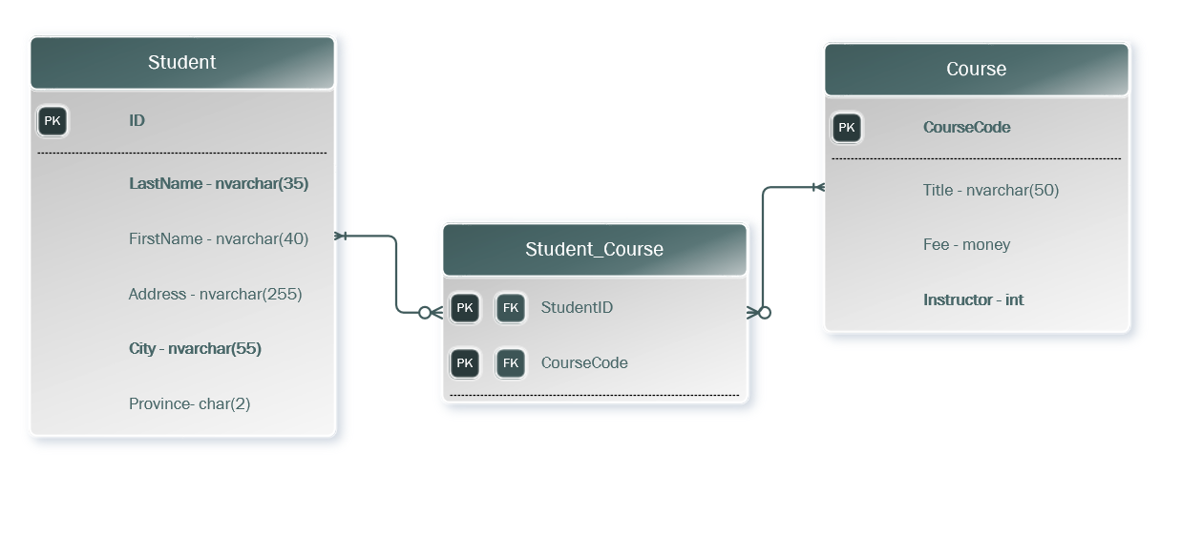

SQL statement:

-- Creating Student Table
CREATE TABLE Student (
ID int NOT NULL,
LastName nvarchar(35) NOT NULL,
FirstName nvarchar(40),
Address nvarchar(255),
PRIMARY KEY (ID)
);

-- Creating Course Table
CREATE TABLE Course (
CourseCode Char(7) PRIMARY KEY,
Title nVarchar(50),
Fee money,
Instructor int Not NULL
);

-- Creating Student_Course Table
CREATE TABLE student_course (
Student_id INT,
CourseCode CHAR(7),
PRIMARY KEY (Student_id, CourseCode),
FOREIGN KEY (Student_id) REFERENCES Student(ID),
FOREIGN KEY (CourseCode) REFERENCES Course(CourseCode)
);

